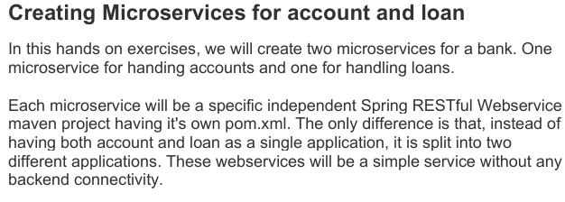

**Source Code:**

**Acc.java:**

**package** com.cognizant.account.controller;

**import** org.springframework.web.bind.annotation.*;

**import** java.util.*;

@RestController

@RequestMapping("/accounts")

**public** **class** Acc {

@GetMapping("/{number}")

**public** Map<String, Object> getAccountDetails(@PathVariable String number) {

Map<String, Object> account = **new** HashMap<>();

account.put("number", number);

account.put("type", "savings");

account.put("balance", 234343);

**return** account;

}

}

**Loan.java:**

**package** com.cognizant.loan.controller;

**import** org.springframework.web.bind.annotation.*;

**import** java.util.*;

@RestController

@RequestMapping("/loans")

**public** **class** Loan {

@GetMapping("/{number}")

**public** Map<String, Object> getLoanDetails(@PathVariable String number) {

Map<String, Object> loan = **new** HashMap<>();

loan.put("number", number);

loan.put("type", "car");

loan.put("loan", 400000);

loan.put("emi", 3258);

loan.put("tenure", 18);

**return** loan;

}

}

**Output:**

